# OUTPATIENT TREATMENT ON DEMAND (OTOD)

**Program Guidelines**

* 1. Definitions

1. Outpatient Treatment on Demand (OTOD): an initiative that aims to improve timely access to outpatient behavioral health care and follow-up for individuals seeking such care utilizing case rates, to pay the Contractor bonuses for high performance for delivering timely intake assessments and connection to routine care while maintaining high levels of patient satisfaction.
2. Bonus Payments: an incentive for Contractors to the meet performance targets detailed in program-specific requirements below.
3. Baseline Period: a six-month period used to calculate Contractor performance targets.
4. Assessment Period: a six-month period in which Contractor improvement is compared to performance targets to determine bonus payments.
5. Payment Period: a six-month period in which Contractor receives bonus payments if performance targets are met in corresponding assessment period.
6. Key Dates Transaction: data transaction that includes Request for Service and First Intake Appointment Offered (see King County Behavioral Health Organization (BHO) Policy and Procedures).
7. Request for Service Date: as defined in the key dates data transaction.
8. First Intake Appointment Offered Date: as defined in key dates data transaction.
9. New Client: client requesting outpatient services from a Contractor who has not received outpatient or long-term carve-out services at that Contractor within the last 90 days.
10. Actual Intake: date that corresponds to the submission of an intake service encounter with an intake evaluation code as specified in the Division of Behavioral Health and Recovery (DHBR) [Service Encounter Reporting Instructions](https://www.dshs.wa.gov/sites/default/files/BHSIA/dbh/Mental%20Health/BHO%20SERI_v201602.1.pdf) for BHOs (SERI).
11. First Routine Service: date corresponding to the submission of the first non-intake, non-crisis service encounter after an outpatient benefit authorization for a New Client.
12. Medical Necessity Criteria: individuals who qualify for King County behavioral health services as defined by the [Mental Health Medical Necessity Criteria](http://www.kingcounty.gov/depts/community-human-services/mental-health-substance-abuse/services/who-we-serve.aspx) and the [Substance Use Disorder Medical Necessity Criteria](http://www.kingcounty.gov/~/media/depts/community-human-services/behavioral-health/BHO_PnPs/Section_05__Outpatient_Services.ashx?la=en) (see King County BHO Policy and Procedures).
    1. Program-Specific Requirements

To receive bonus payments for providing OTOD, Contractors shall meet the following requirements:

* + 1. Document, by November 30, 2017, planned and active processes to support Treatment on Demand. The County will not require the Contractor to deploy specific strategies, such as Open Access, but will require the Contractor to report what strategies are chosen and how they are implemented. Please indicate in your document whether your agency is currently, or will be, implementing Open (walk-in) Access to outpatient care and the extent to which it is/will be implemented (e.g., all mental health and substance use disorder, partial, etc.). If your agency already provides walk-in access, please indicate when this form of access to outpatient care was initiated.
    2. Participate in the evaluation of OTOD, including collection of patient satisfaction data.
    3. Performance incentive requirements:

a. The County will establish Contractor-specific growth targets toward a county goal for each performance metric. Contractors that meet their growth target or exceed the county goal during an assessment period will receive the full bonus for that metric in the corresponding payment period. An overview of these terms is below. To facilitate Contractors’ ongoing understanding of performance, the County will provide Contractors with monthly performance data over the trailing six-month period.

**Contractor growth target Calculation Methodology**

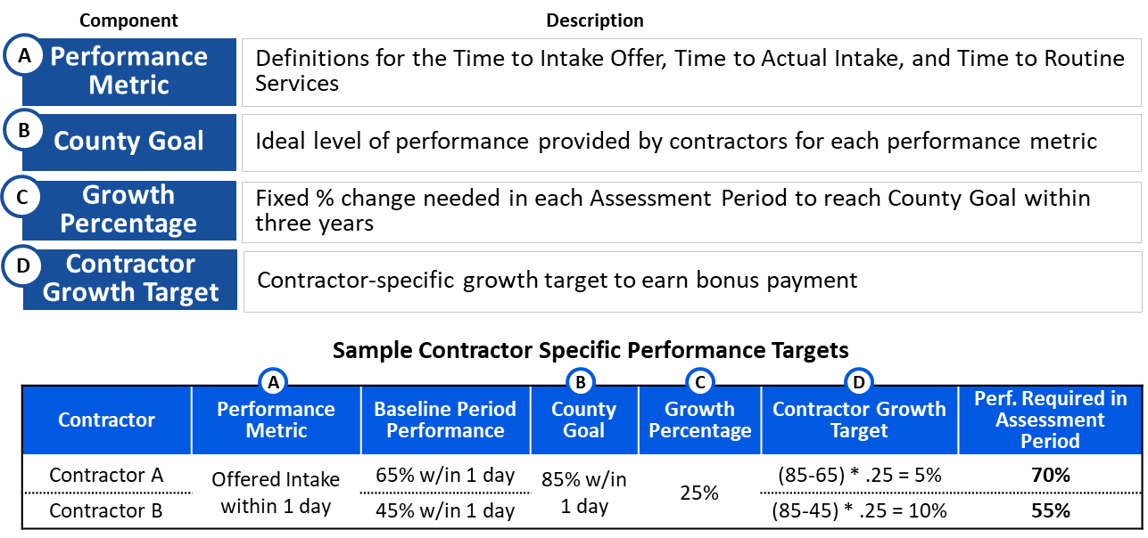

* + - 1. Performance Metrics: the assessed time between two dates[1] shall be:

1. Time to Intake Offer:
$$\frac{\# of New Clients with First Intake Appt Offered on same or next day of Request for Service}{\# of Authorizations for New Clients with Request for Service}$$

2. Time to Actual Intake:
$$\frac{\# of New Clients receiving First Actual Intake within 4 days of Request for Service}{\# of Authorizations for New Clients with Request for Service}$$

3. Time to Routine Service:
   * + 1. Growth Target Calculation: A Contractor’s per period growth target is calculated as follows:

$$Contractor Growth Target=$$

$$\left(County Goal-Contractor performance in Basline Period\right)*Growth Percentage$$

It is understood that Contractor performance may decline in certain assessment periods. If this occurs, the County will use the prior assessment period’s required performance level to determine bonus payment instead of recalculating a lower target.

* + - 1. County Goals for each Performance Metric:

1. Time to Intake Offer: shall be 85 percent of clients receiving first intake appointment offered within the same or next day of request for service;
2. Time to Actual Intake: shall be 80 percent of clients receiving first actual intake within four days of request for service; and
3. Time to Routine Service: shall be 70 percent of clients receiving first routine service within seven days of first actual intake.
   * + 1. Growth Percentages for each Performance Metric: (shown below) the consistent percentage of the difference between the county goal and any Contractor’s baseline period performance that must be achieved over any semi-annual assessment period to receive bonus payment in the corresponding payment period. A Contractor performing above the county goal will receive the full bonus for that metric.
4. Time to Intake Offer – 25 percent of difference each Assessment Period
5. Time to Actual Intake – 35 percent of difference each Assessment Period
6. Time to Routine Service – 35 percent of difference each Assessment Period
   * + 1. IncentiveSize and Performance Metric Weighting:
7. If the Contractor meets performance targets in a given assessment period, the Contractor shall earn a two percent bonus on their uniform benefit on all outpatient benefits during the corresponding payment period.[2]
8. For each performance metric, Contractor performance is judged on an all-or-nothing basis (i.e., met the Contractor growth target or county goal – or did not). If a Contractor does not meet their growth target/county goal for a specific performance metric, they are not eligible for a bonus payment for that metric.
9. The Contractor shall receive payment based on the following weights:

Performance Metric Case rate bonus % of total bonus pool

Time to Intake Offer 0.5 % 25%

Time to Actual Intake 0.5 % 25%

Time to Routine Service 1.0 % 50%

Example: The Contractor meets Time to Actual Intake (25%) and Time to Routine Service (50%) goals during an assessment period but does not meet Time to Intake Offer (25%) goal. That Contractor would receive 75 percent of the maximum bonus payment, or 1.5 percent bonus on outpatient benefits during the corresponding payment period.

* + - 1. Managing Missing Data

Each of the proposed performance metrics is calculated as the difference between two date elements submitted by the Contractor. When calculating performance levels, the County will exclude authorization records in which the first date is missing and treat instances in which the second date is missing as a non-success. The table below lays out how each data element is treated for each performance metric.

|  |  |  |
| --- | --- | --- |
| **Performance Metric** | **First Date** | **Second Date** |
| Time to Intake Offer | Request for Service | First Offered Intake |
| Time to Actual Intake | Request for Service | Actual Intake |
| Time to Routine Service | Actual Intake | First Routine Service |

If the County notices a substantial change in data quality or completeness for data elements involved in this initiative, the County will initiate a discussion with the Contractor. If the issue cannot be resolved, it will be forwarded to the contract monitor to determine whether it may impact incentive payments.

* + - 1. Patient Satisfaction Qualifier Metric: *will be defined with participating agencies.*

1. Payment Timing
2. October, 2017-March, 2018: Full bonus payment (2% of Outpatient Benefits) will be made on the 15th of each month for the given month (e.g., December 15, 2017 for December, 2017, etc.) regardless of actual performance.
3. April, 2018-September, 2018: The County will calculate earned bonuses during March, 2018 to begin payment in April, 2018, in order to take into account data submission lags. The monthly payments for this period will be based on the Contractors’ performance during the period August, 2017-January, 2018 to allow for a 30-day data submission lag and a month for analysis and reporting. Recognizing that this includes some months prior to the initiation of the incentive program, the County will require only ***half*** of the expected growth percentage (relative to section 3.e. above):

Time to Intake Offer – 12.5%

Time to Actual Intake – 17.5%

Time to Routine Service – 17.5%

1. October 2018-March 2019 and beyond. The County will calculate earned bonuses during September 2018 to begin payment in October 2018. The monthly payments for this period will be based on the Contractor’s performance during the period February 2018-July 2018 to allow for a 30-day data submission lag and a month for analysis and reporting. Performance calculation will occur as defined in section 3a-h.

**Timeline for Baseline, Assessment, and Payment Periods[3]**



1. Each of these calculations are exclusive of weekends (i.e., Saturday / Sunday/ [King County Holidays](http://www.kingcounty.gov/courts/district-court/court-dates-and-fees/holiday-closures.aspx) (<http://www.kingcounty.gov/courts/district-court/court-dates-and-fees/holiday-closures.aspx>)
2. Intake-only authorizations are included in calculation of Time to Intake Offer and Time to Actual Intake metrics; however these authorizations are not included in Outpatient Benefits eligible for receiving bonuses.
3. Since the first Payment Period (October, 2017 – March, 2018) is *not* contingent on performance, there is no Baseline or Assessment.