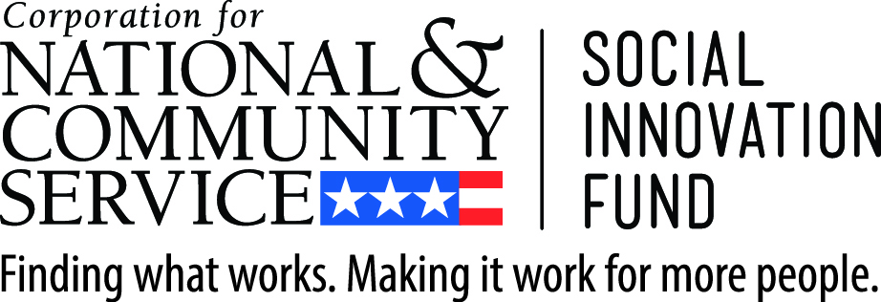

Third Sector Capital Partners, Inc. & the Stanford Center on Poverty & Inequality

Administrative Data Pilot Competition

Letter of Interest form

Note: Applicants may complete and fill out this form, submitting to SIFcompetition@thirdsectorcap.org, or complete an online version of the Letter of Interest form here.

Potential applicants are encouraged, but not required, to submit this form. Those who submit will be placed on an initial listserv about the competition launch and will be proactively contacted to sign up for informational calls. Information included in this form will not be used in the scoring or reviewing of submitted applications. Submit by January 25, 2017 at 5:00 p.m. PST

- Applicant Information

Organization Name:
Lead Respondent Name:
Title/Role:
Location:
Email Address:
Phone Number:

- Preliminary Application Information

Type of Organization:

City / County Agency or Department

City / County Executive Office

State Agency or Department

Service Provider (note: application requires lead government applicant)

Academic / Research Institution (note: application requires lead government applicant)

Issue Area of Potential Project (choose all that apply):

Criminal Justice

Housing

Child Welfare

Workforce Development

Education / Youth Development

Health

Homelessness

- Additional Application Partners

Please provide a brief description of any additional organizations that may participate in the application, including, if possible, contact information for such partners (name, department/office, email, etc).

- Potential Application Focus / Project

Please provide a brief description of any target population(s), interventions, and/or service providers you are considering for this opportunity. This may include projects under consideration or those already operating in your community. If available, please provide a link to any supporting data/materials or project documents related to the potential area of focus.

- Questions

Please list any specific questions you would like Third Sector, Stanford, or other project partners to address, whether it is through an FAQ document, the upcoming second webinar, or individual follow-up calls.

